

Cars for Sale
The Embassy of Sri Lanka, Abu Dhabi, United Arab Emirates invites qualified / eligible bidders for submission of sealed bids for the purchase of the following used Embassy vehicles:

Vehicle 01

Type : Mercedes Benz
Model : E 250 Saloon
Year : 2010
Transmission : 7-Speed Automatic
Fuel Type : Petrol
Mileage : 413,711 km
Engine Capacity: 4 Cylinders
Colour : Black

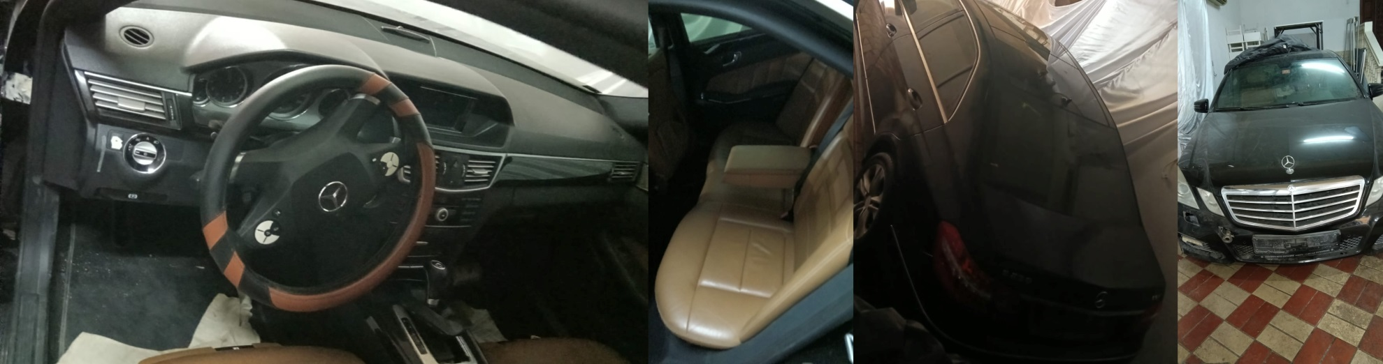

Vehicle 02

Type : Toyota
Model : Camry
Year : 2014
Transmission : 6-Speed Automatic
Fuel Type : Petrol
Mileage : 335,166 km
Engine Capacity: 4 Cylinders
Colour : Black

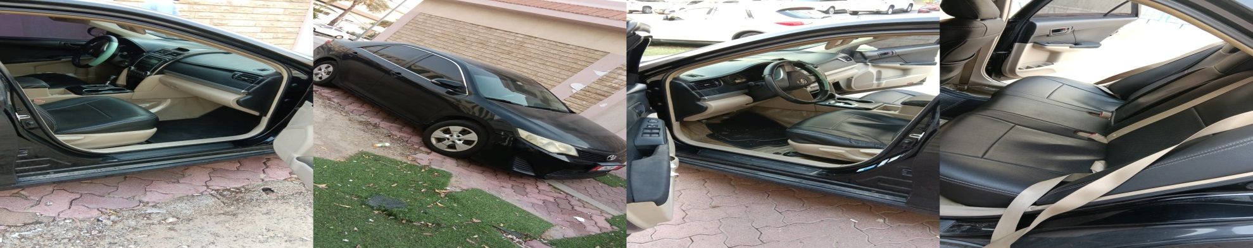

Inspection of the vehicle :
Date and Time: from 30th July to 12 August 2026 from 0900 – 1700 hrs (weekdays only)
Address : Embassy of Sri Lanka, Villa 42, Salam Street, Al Danah, Abu Dhabi

Tender Documents and Vehicle Information:
- Tender documents and vehicle information can be obtained from the Embassy upon payment of a non-refundable fee of AED 50/- for each vehicle.

- Interested bidders are required to pay a refundable security deposit of AED 500/- for each vehicle at the time of obtaining the tender documents. An official receipt signed by an authorized Embassy official will be issued as acknowledgement of the payment.

- The successful bidder shall bear all the payments related to the transfer of the vehicle.

Contact Information for further details :
Tender Opening Details:
- Date: 13 August 2026
- Time: 10:30 a.m.
- Location: Embassy of Sri Lanka, Abu Dhabi (Villa 42, Salam Street)

- Tel: +971 2 631 6444 / +971 2 634 6481
- Email: slemb.abudhabi@mfa.gov.lk

Embassy Address:
Embassy of Sri Lanka
Villa No. 42, Sector E 18/3, Salam Street
P.O. Box: 46534
Abu Dhabi, United Arab Emirates

Note: The Embassy of Sri Lanka reserves the right to accept or reject any bid and/or withdraw the vehicles from sale without prior notice.

29 July 2026

